NAVODILA ZA DELO PRI POUKU ANGLEŠČINE V 4. RAZREDU (8. 4. 2020)

THE SEASONS

First check your homework from yesterday. Preveri in popravi včerajšnjo nalogo.

DZ 28/1
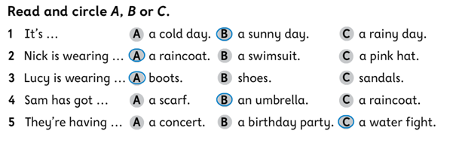
DZ 28/2
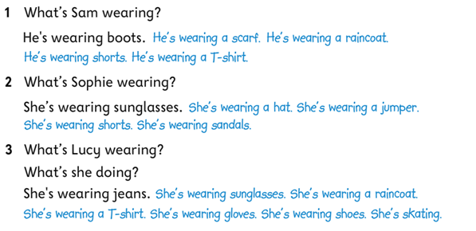
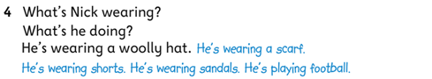

RAZLAGA
Open your notebook and write the title THE SEASONS. Then look out the window and check the weather. Copy the questions in your notebook and answer them. Poglej skozi okno in preveri vreme. Prepiši vprašanja v zvezek in odgovori nanje.
- How’s the weather today?
- What month is now? It’s April.
- What seasons is now? It’s spring.
- What is before spring? Winter.
- What is after spring? Summer.
- What season is it when you go to school? It’s autumn.

You know a lot of vocabulary about spring from the second class. Let’s review.
Veliko besedišča o pomladi poznaš že iz 2. razreda. Ponoviva.

What are you going to learn about today? Today we will talk about different seasons. There are four seasons: spring, summer, autumn and winter. What seasons is your birthday in? Write the answer in your notebook: My birthday is in ____________.
Kaj se boš učil danes? O letnih časih. Štiri poznaš, kajne? Poletje, pomlad, jesen in zima. V katerem letnem času imaš rojstni dan? V zvezek napiši poved in jo dopolni: My birthday is in ______________________.

U 35/1: open your book on page 35 and look at the picture. What can you see? Is there a girl making a snowman? What season is it? Is there a boy playing with leaves? What season is it? Is there a boy jumping in the puddle? What season is it? Is there a girl licking an ice cream? What season is it?
Odpri učbenik na strani 35 in si poglej sliko zgoraj. Kaj vidiš? Vidiš deklico, ki dela snežaka? Kateri letni čas je? Vidiš dečka, ki se igra z listjem? Kateri letni čas je? Vidiš dečka, ki skače v luži? Kateri letni čas je? Vidiš deklico, ki liže sladoled? Kateri letni čas je?

U 35/2: listen to the song and sing about the seasons! Read the song.
Poslušaj pesem in zapoj o letnih časih! Preberi pesem.

DZ 29/1: listen and read the song again. Some words are missing. Find the correct word in the box and write it. Znova zapoj in preberi pesem in poglej, kaj manjka. Vstavi besed, poišči jih v okvirju.

DZ 29/2: look at the picture and write the seasons. Poglej si sliko in napiši letni čas.

Explorer's Quest: preglej učbenik do straneh 34 in 35, napni možgane in poišči nove črke za skrivno sporočilo.

HOMEWORK

Nariši štiri večje kroge v zvezek. Vanje zapiši imena letnih časov po angleško. Premisli, katera oblačila, ki jih poznaš v angleščini, boš dopisal v posamezne kroge. Npr. shorts = summer, sandals = summer, woolly hat = winter

SUMMER
WINTER
SPRING
AUTUMN
sandals, shorts, ….

a woolly hat, ...

