Kako si lahko pomagamo pri risanju? - Spletne strani

Pozdravljeni učenci in učenke!
Vsi, ki radi rišete v prostem času, lahko najdete na spodnjih
povezavah nekaj navdiha. Poskusite! Vaja dela mojstra.

Lep pozdrav!
učiteljica Alenka Mejaš

- https://www.youtube.com/watch?v=fRavJtuv6po

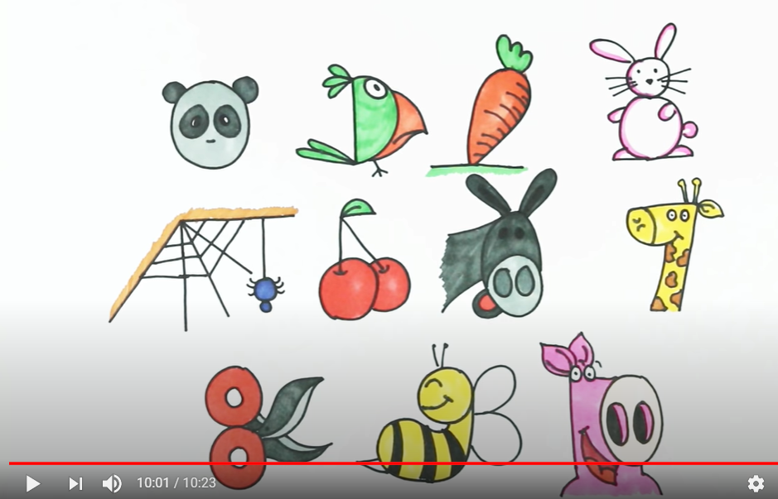

- https://www.youtube.com/watch?v=VvIqKOTvTsA
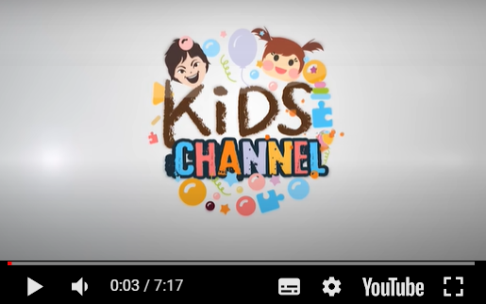

- https://www.youtube.com/watch?v=QhC-OvbL9jY
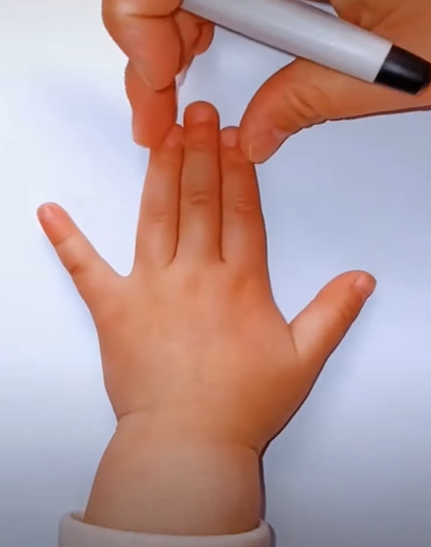

- https://www.youtube.com/watch?v=ma-U7i8s5q8

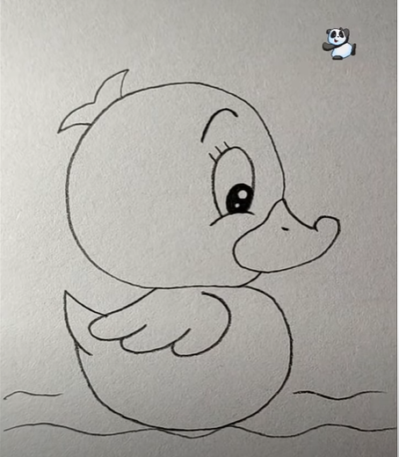

- https://www.youtube.com/watch?v=W4lvxPhmI38

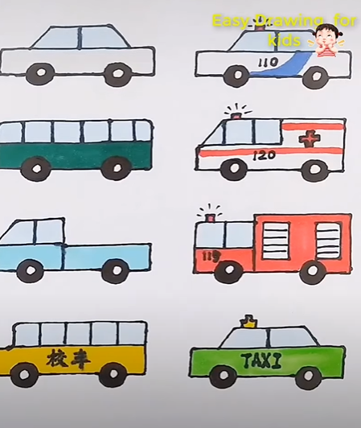

- https://www.youtube.com/watch?v=5XAUe6-oL94

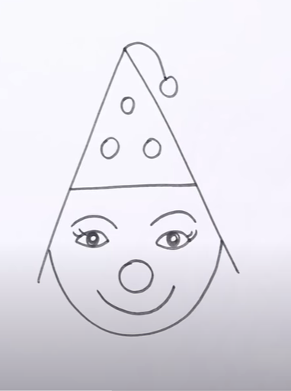

- https://www.youtube.com/watch?v=AnFCD2JbN0A

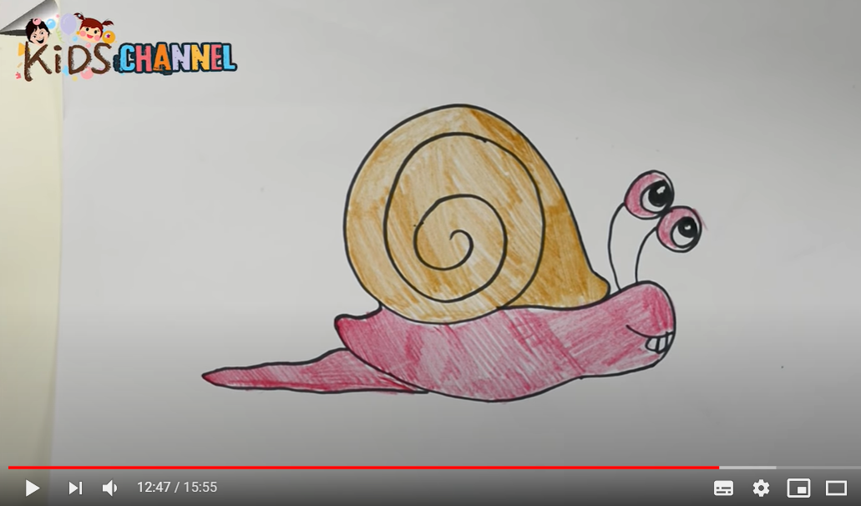

- https://www.youtube.com/watch?time_continue=36&v=7SWvlUd2at8&feature=emb_title

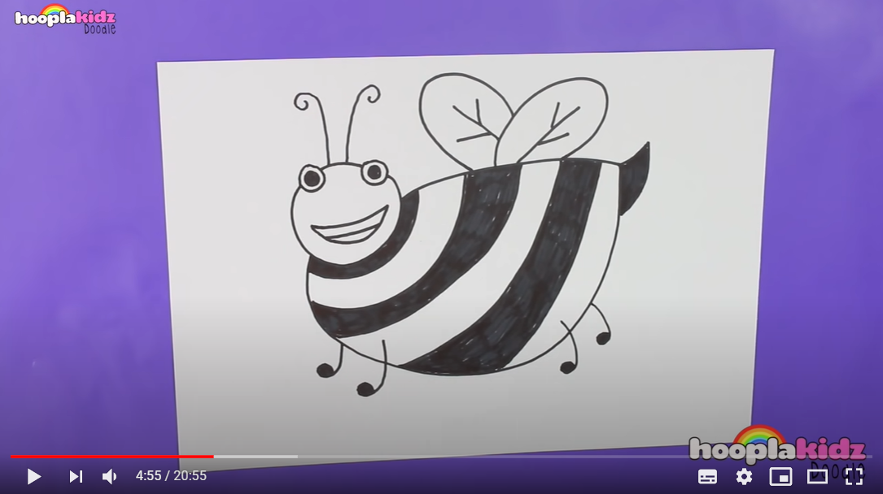

- https://www.youtube.com/watch?v=TWvHd7AKGpA&list=RDCMUCtkd62HsnkCr6INcVexlsnw&start_radio=1&t=19&t=23
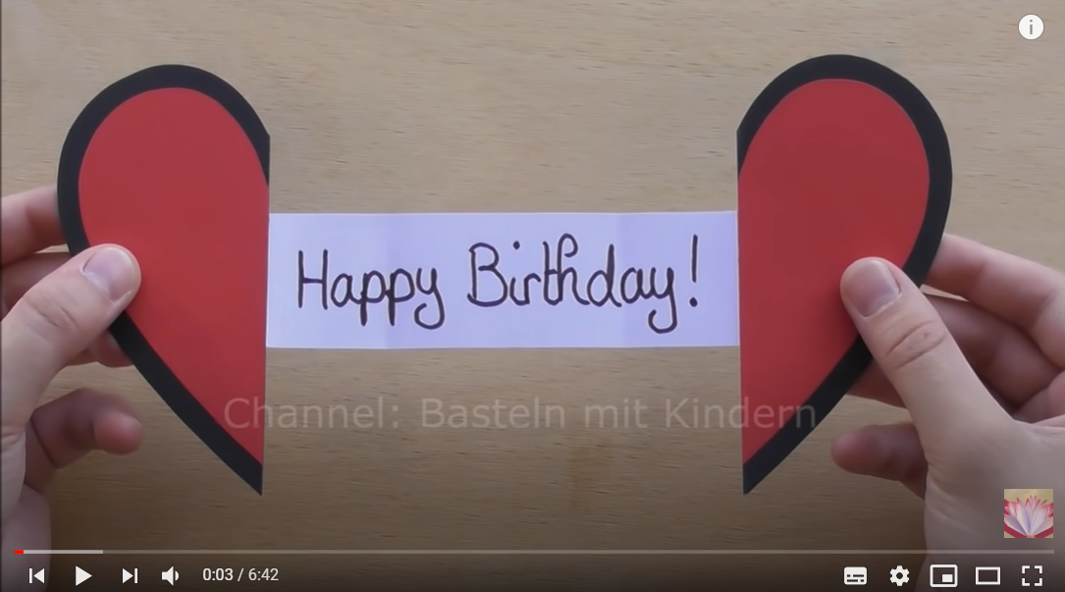

- https://www.youtube.com/watch?v=_FWs_rFXZs&list=RDCMUCtkd62HsnkCr6INcVexlsnw&index=8

